**Lauren Pelayo**

**Alex Lundin**

**Thomas Lindholm**

PHYS 2125.104.603

TA: Mathew Fong

Sep. 20, 2015

**Lab 3: Measurements**

**Table of Contents**

**1.) Analysis Questions**

**2.) Data**

**3.) Calculations**

1.) Analysis:

**(Q5.1)**

1. Mean, Standard Deviation and SEOM

|  |  |  |  |  |  |  |  |  |  |
| --- | --- | --- | --- | --- | --- | --- | --- | --- | --- |
|  | Mean | | | Standard Deviation | | | SEOM | | |
|  | Length | Spr Dia | W Dia | Length | Spr Dia | W Dia | Length | Spr Dia | W Dia |
| Red | 0.132 | 0.014 | 0.001 | 7.8E-04 | 7.8E-04 | 0.0E+00 | 0.0005 | 0.0005 | 0.0000 |
| Blue | 0.130 | 0.013 | 0.001 | 2.1E-03 | 0.0E+00 | 0.0E+00 | 0.0012 | 0.0000 | 0.0000 |
| Green | 0.131 | 0.0140 | 0.0009 | 7.8E-04 | 0.0E+00 | 6.7E-05 | 0.0005 | 0.0000 | 0.0000 |

1. Circumference

|  |  |  |  |
| --- | --- | --- | --- |
|  | Circumference | Error | Uncertainty |
| Red | 0.04503 | 0.00045 | 0.00143 |
| Blue | 0.04084 | 0.00005 | 0.00016 |
| Green | 0.04398 | 0.00005 | 0.00016 |

1. Length and Volume

|  |  |  |  |  |  |  |
| --- | --- | --- | --- | --- | --- | --- |
|  | Length | Error | Uncertainty | Volume | Error | Uncertainty |
| Red | 7.38484 | 0.00067 | 0.23396 | 0.00119 | 0.00067 | 0.004943 |
| Blue | 5.67686 | 0.00134 | 0.14388 | 0.00075 | 0.00134 | 0.003535 |
| Green | 5.84965 | 0.00067 | 0.02089 | 0.00090 | 0.00067 | 0.002920 |

1. Wire density

|  |  |  |  |
| --- | --- | --- | --- |
|  | Density | Error | Uncertainty |
| Red | 23.5 | 0.007200 | 0.169412 |
| Blue | 39.8 | 0.001840 | 0.07360 |
| Green | 35.5 | 0.007200 | 0.256000 |

1. Number of coils

|  |  |  |  |
| --- | --- | --- | --- |
|  | # Coils | Error | Uncertainty |
| Red | 164.0 | 0.809149 | 0.182774 |
| Blue | 139.0 | 0.002449 | 0.193213 |
| Green | 133.0 | 0.007049 | 0.095765 |

**(Q5.2.1)**

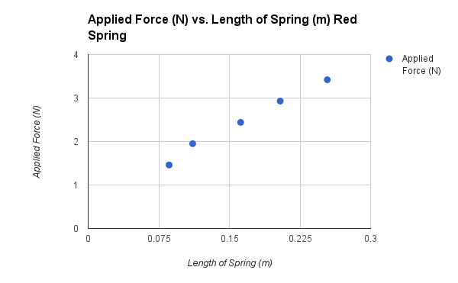

Plot 1: Applied force vs. length of spring for Red Spring taken from table 2

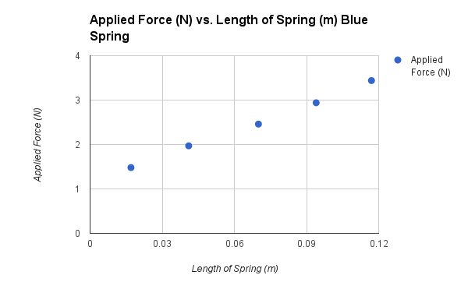

Plot 2: Applied force vs. length of spring for Blue Spring taken from table 2

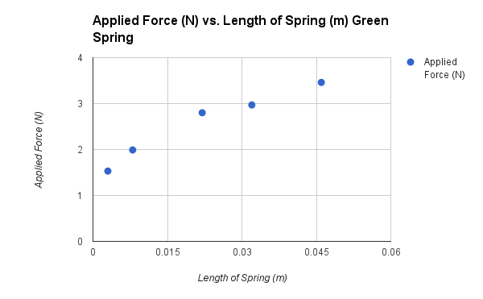

Plot 3: Applied force vs. length of spring for Green spring taken from table 2

**(Q5.2.2)**

We know that the equation to find the spring constant is $k=\frac{F}{Δx}$**.** If we take the data that we have from table 2 and plot them, the slope should give us the value $k.$ We can use the slope formula $\frac{y_{2}-y_{1}}{x_{2}-x_{1}}$ For the red spring we would plug in the data we recorded into the formula to make $\frac{3.42-1.46}{.254-.086}=11.7$

So the red spring constant is 11.7 and if we repeat the same steps for the other two springs, we get that the blue spring constant is 19.6 and the green spring constant is 44.9.

**(Q5.2.3)**

There was a relationship between the number of coils and the spring constant. The red spring had the most amount of coils and also the lowest spring constant. The green spring had the least amount of coils and the highest spring constant. There was also a relationship between the mass of the springs. The red spring had the lowest mass of the three and also the lowest spring constant. The green spring had the highest mass and the highest spring constant. There was a relationship between the change in length of the spring and the spring constant. The red spring had the highest change in length and also the lowest spring constant. The green spring had the smallest change in length and the highest spring constant.

2.) Data:

|  |  |  |  |  |  |
| --- | --- | --- | --- | --- | --- |
|  | Mass (kg) | Length (m) | Spring Diameter (m) | Wire Diameter (m) | # Coils |
| Red | .028 | .131 | .140 | .010 | 164 |
|  |  | .132 | .150 | .010 |  |
|  |  | .132 | .140 | .010 |  |
| Blue | .030 | .128 | .130 | .010 | 139 |
|  |  | .131 | .130 | .010 |  |
|  |  | .130 | .130 | .010 |  |
| Green | .032 | .130 | .140 | .009 | 133 |
|  |  | .131 | .140 | .009 |  |
|  |  | .131 | .140 | .008 |  |

Table 1: Data table for spring measurements

|  |  |  |  |
| --- | --- | --- | --- |
|  | Mass Added (g) | Force (N) | Change in Length (m) |
| Red | 100 | 1.46 | .086 |
|  | 150 | 1.95 | .111 |
|  | 200 | 2.44 | .162 |
|  | 250 | 2.93 | .204 |
|  | 300 | 3.42 | .254 |
| Blue | 100 | 1.48 | .017 |
|  | 150 | 1.97 | .041 |
|  | 200 | 2.46 | .070 |
|  | 250 | 2.94 | .094 |
|  | 300 | 3.44 | .117 |
| Green | 100 | 1.53 | .003 |
|  | 150 | 1.99 | .008 |
|  | 200 | 2.80 | .022 |
|  | 250 | 2.97 | .032 |
|  | 300 | 3.46 | .046 |

Table 2: Data table for plotting force vs. change in length

3.) Calculations:

Sample calculations from Table 1:

$Mean = (L _{1}^{}+ L _{2}^{}+ L _{3}^{}) / 3$

Example: Length of Red Spring

$Mean = (L _{1}^{}+ L _{2}^{}+ L _{3}^{}) / 3$

$Mean = (.131+ .132 + .132) / 3$

$$Mean = .132$$

$Standard Deviation =\sqrt{[ \sum_{i=1}^{n}{}(M_{i}^{}-M){}^{2} ] / (number of measurements -1)}$

Example: Standard Deviation of Red Spring Length

$[ \sum_{i=1}^{n}{}(M_{i}^{}-M){}^{2} ]$

$$Mean =M = .132$$

${(M}_{1}^{}-M ) = .131-.132 = -.001$

$(M_{2}^{}-M) = .132 - .132 = 0$

${(M}_{3}^{}-M) = .132- .132 = 0$

$$[ \sum_{i=1}^{n}{}(M_{i}^{}-M){}^{2} ] = (-.0{01)}^{2}+({0)}^{2}+({0)}^{2} = .000001$$

$$\sqrt{[ \sum_{i=1}^{n}{}(M_{i}^{}-M){}^{2} ] / (n-1) } = \sqrt{[ .000001 ] / (2) }= .000774$$

$SEOM = (Standard Deviation) / \sqrt{\# of measurements}$

Example: SEOM of Red Spring Length

$SEOM = (Standard Deviation) / \sqrt{3}$

$SEOM = (.000774) / \sqrt{3}$

$$SEOM = .000446$$

$Circumference = Diameter * PI$

Example: Red Circumference

$Circumference = .014 * PI$

$Circumference = .04503$

$Error = \sqrt{(measuring error)^{2} + (SEOM)^{2} }$

Example: Error of calipers

$error = \sqrt{(.00005)^{2} + (.000{5)}^{2} }$

$error =.00045$

$$Uncertainty =[((measured value)+(error)) -((measured value)-(error))] / 2$$

Example:

Uncertainty of Red Spring

Our measured value for circumference was Diameter, so we propagate error off that measurement to find uncertainty of circumference.

$$Circumference = Diameter * PI$$

$Circumference Uncertainty =[ ((Mean Diameter + error)*PI) -( (Mean Diameter - error) * PI)] /2$

$=[ (High Circumference) -(Low Circumference) ] / 2$

$=[( (.014+.00045) * PI) -( (.014 - .00045)*PI) ] / 2$

= .00045